Git is a version control system that developers install locally on their personal computers to interact with remote repository hosting services for sharing and managing code repository.
Github is an example of remote repository hosting services.
- Remote repository hosting services are typically cloud-based, meaning they run on servers hosted on the internet rather than on local machines.
- This allows developers to access their code repositories from anywhere, as long as they have an internet connection.

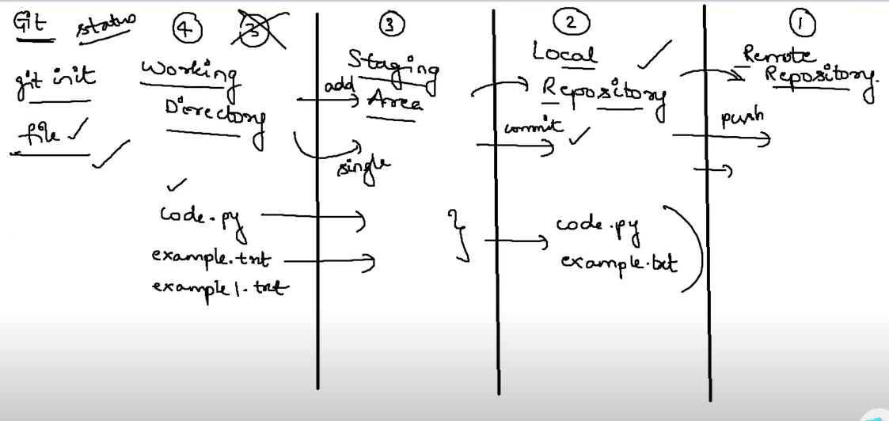

Branches: After committing things into a particular branch, we make a pull request and admin have to accept to merge it in the main code
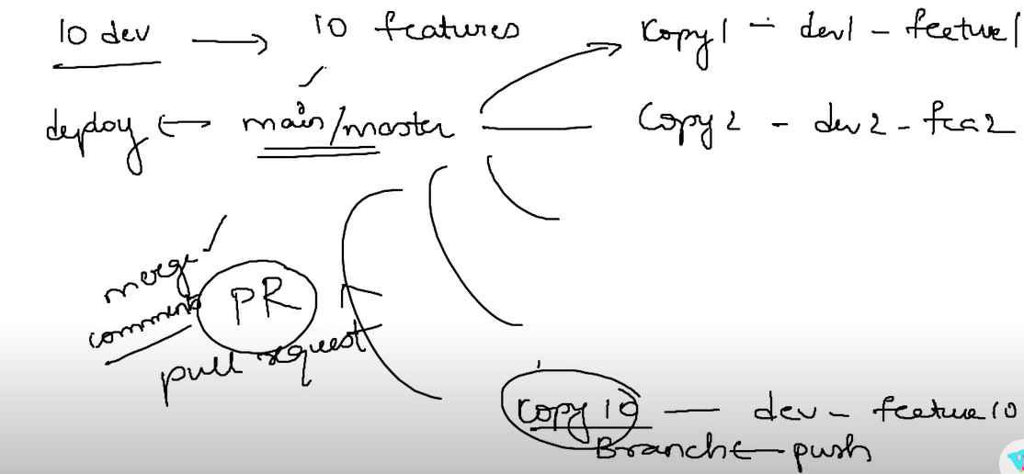
Open the current working directory(file1, file2, file3) in cmd prompt
git init – initialize the git
git status – status showing current branch, untracked files and files in staging areas that are required to
commit
git add file1 – adding a particular file inside staging area. Without staging area we have to commit
all files at a time
git add file2 – considering that we are going to commit second file alse
If we want to add all the file, then enter ( git add . )
git commit -m “committing file1 and file2” – Files are committed to the local repository and message is
displayed to the admin when we are making a pull request.

Now we have to push files in local repository to remote repository:
Open github and create a new repository for example lets name it git_tuts.
Copy the path of the repository
git remote add origin copied_link - we are selecting the remote repository
At this stage we have to select the branch of the remote repository in which we want to push
git branch – show the current selected branch
If you are not ok with it, move to another or create a new
git checkout -b branch_name – move to the branch named branch_name, if it doesn’t exists then
create a new branch named branch_name.
There will be a main branch to our repository, and we will make pull requests from branch_name to
merge it into main branch.
git push – files inside the local repository are pushed inside branch_name branch of remote repository
git_tuts.
Now you can open github, and can observe that file1 and file2 are present inside the branch_name
branch of remote repository git_tuts.
Now we can make pull requests.

.
Tracked files:
These are files Git knows about because you staged (git add) and committed (git commit) them.
Git monitors changes in these files.
Untracked files:
Files in your working directory that you never git add.
Git ignores them completely.

When you checkout a branch (git checkout <branch>) changes occurred in file explorer:
1.Git looks at all tracked files in the current branch.
It modifies, replaces, or deletes them in your working directory(file explorer) to match the snapshot(tracked files) of the local branch you are switching to.
2.Git ignores untracked files.
It does not delete, modify, or move them.
This is why files you just copied but never added remain in the folder.
3.Git checks for files present in snapshot but missing in working directory → Git adds them
Additional points:
If a tracked folder contains untracked files, Git cannot delete the folder

